create database intern;

use intern;

-- response table

create table response(

customer_id varchar(255) primary key,

response numeric

);

load data infile 'C:/ProgramData/MySQL/MySQL Server 8.0/Uploads/Retail_Data_Response.csv'

into table response

fields terminated by ','

lines terminated by '\n'

ignore 1 rows;

select * from response where customer_id='CS1763';

-- transaction table

create table transaction_(

customer_id varchar(255),

trans_date varchar(255),

tran_amount numeric

);

load data infile 'C:/ProgramData/MySQL/MySQL Server 8.0/Uploads/Retail_Data_Transactions.csv'

into table transaction_

fields terminated by ','

ignore 1 rows;

**-- Response Distribution**

SELECT

SUM(CASE WHEN response = 1 THEN 1 ELSE 0 END) AS positive_responses,

SUM(CASE WHEN response = 0 THEN 1 ELSE 0 END) AS negative_responses,

COUNT(*) AS total_responses,

(SUM(CASE WHEN response = 1 THEN 1 ELSE 0 END) * 100.0 / COUNT(*)) AS percentage_positive,

(SUM(CASE WHEN response = 0 THEN 1 ELSE 0 END) * 100.0 / COUNT(*)) AS percentage_negative

FROM response;

-- Summary Statistics

SELECT

AVG(response) AS average_response,

MIN(response) AS min_response,

MAX(response) AS max_response

FROM response;

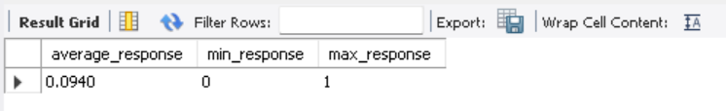

**Customer Response Distribution:**

SELECT

customer_id,

SUM(CASE WHEN response = 1 THEN 1 ELSE 0 END) AS positive_responses,

SUM(CASE WHEN response = 0 THEN 1 ELSE 0 END) AS negative_responses,

COUNT(*) AS total_responses

FROM response

GROUP BY customer_id;

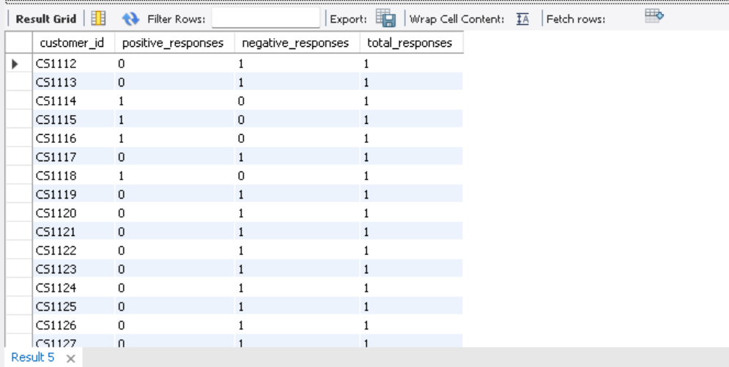

-- Total Transaction Amount per Customer --

SELECT

customer_id,

SUM(tran_amount) AS total_transaction_amount

FROM transaction_

GROUP BY customer_id;

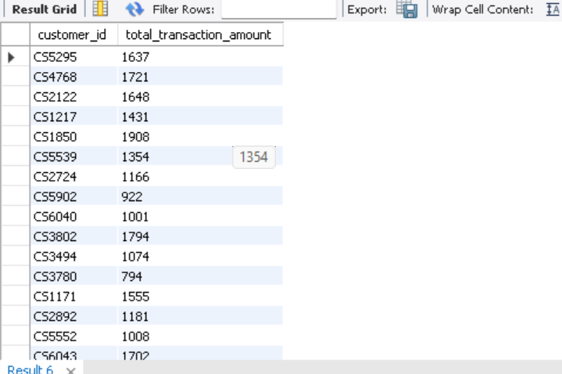

**-- Customer with the Highest Transaction Amount --**

SELECT

customer_id,

SUM(tran_amount) AS total_transaction_amount

FROM transaction_

GROUP BY customer_id

ORDER BY total_transaction_amount DESC

LIMIT 5;

